The Demographics of Over-education in the United States, 1971-2006
(Final Paper)

China Layne

Department of Sociology
State University of New York
Albany, NY 12222
Phone: 518-442-4676
Fax: 518-442-4936
E-mail: clayne237@hotmail.com
February 2010

In this research, I addressed the question of race and gender differences in over-qualification. Over-qualified workers have more education than is common for their occupation. The study uses a sample of workers aged 25-65 who are white, black, or Hispanic collected from the Current Population Survey for 1971-2006. Over-education is calculated using a range measure adapted from the previous work of Sullivan (1978) that considers the educational distribution within occupations. Following the results of previous research on employment outcomes, I hypothesized that white women and minority workers would have higher odds of over-education compared to white men. However, my results show that white women and minority workers have much lower odds of over-qualification than white men. This project exploits the advantages of multi-level analysis by modeling the effects of occupation and year level characteristics on a worker’s odds of over-education. With this, the study is able to provide a possible explanation of the racial and gender differences in the odds of over-education, occupational segregation. This research addresses a large gap in the literature on over-education in the United States by providing data on and analysis of racial and gender differences in over-qualification.

In 2005, fully 29% of American workers ages 25-65 had at least a bachelor's degree (American Community Survey, 2005). However, the BLS estimated that the share of employment in jobs that require at least a bachelor's degree was only 22% in the same year (BLS, 1995). We can readily see that the supply of college-educated workers outstrips the labor market demand. So what happens to the "extra" 12.6 million working age, college-educated Americans? These people essentially become over-educated workers; workers who have higher levels of education than is common for or required of the occupations in which they are employed. For the contemporary period, over-education is an increasingly common experience for American workers. This research found that over-qualification grew from 10.2% of workers in 1971 to 27.1% of workers in 2006, with over the year growth in almost every year of the time period (table 1).
Numerous studies have detailed the negative consequences, both social and economic, of being an over-educated worker. Hersch (1991) and Sicherman (1991), in separate studies, find that over-educated workers have higher rates of job mobility than workers who are not over-educated. Hersch (1991), Vaisey (2006), Smith (1986), and Burris (1983) find that over-educated workers are less satisfied with their jobs. Finally, there is a very large body of research that details the earnings disadvantage of being over-educated. Several researchers note that although years of over-education have a positive return on earnings, this return is significantly less than the earnings return to years of education that are adequate for the job (Daly et al., 2000; Vaisey, 2006; Hartog, 2000; Rumberger, 1987; Cohn and Kahn, 1995). These researchers note that over-educated workers earn more than other workers in the same job who are not over-educated, but they earn less than workers with the same level of education who are in jobs for which they are not over-educated (Sicherman, 1991).
This project explores three primary questions. First, the research exploits the advantages of multilevel analysis to quantify the extent to which workers’ odds of over-education depend on the specific occupation and year in which they work. Second, the study examines which workers are more likely to be over-educated for their jobs. Finally, the project considers whether human capital traits, such as work experience, or ascriptive characteristics such as race, ethnicity, and gender are better predictors of a worker’s likelihood of being over-educated.

Race, Gender, and Human Capital Differences in Over-education

Even though over-education has become an increasingly common experience for American workers, not all workers are as equally likely to be over-qualified for their jobs. Several researchers, such as Vaisey (2006) and Burris (1983), find that non-white workers have higher over-education rates than white workers. On the other hand, Clogg and Shockey (1984) find lower rates of over-education for black men and women than for non-black (white) men. Similarly, the studies disagree on whether there is a gender difference in over-qualification. Groot et al. (2000), in a meta-analysis of over-education studies, find no gender difference in rates of over-education. However, Clogg and Shockey (1984) find that non-black (white) women had a lower rate of over-qualification than did non-black (white) men for 1980.
A major gap in the literature on over-education is highlighted by the lack of consensus about race and gender differences in over-qualification. Part of the reason for the lack of consensus is due to the fact that many of the studies on over-education either did not include minority workers at all (McGoldrick, 1996; Daly et al., 2000; Verduggo and Verduggo, 1989), don't include an analysis of race / ethnic differences in over-education (Smith, 1986; Rumberger, 1987), or don't include an analysis of gender differences in over-qualification (Sicherman, 1991; Rodriguez, 1978; Verduggo and Verduggo, 1989). This research helps fill this gap in the literature by providing both data for, and analysis of, racial, ethnic, and gender differences in over-qualification for the entire 1971-2006 period.
There is, however, more agreement about the greater likelihood for younger and less experienced workers to be over-educated. Burris (1983) finds that workers under 35 years old have higher rates of over-education than workers 35 years and older. Sicherman (1991) also finds higher levels of over-education for less experienced (and presumably younger) workers. In one partially dissenting finding, Vaisey (2006) argues that younger workers had higher rates of over-qualification for 1972-1992, but not for 1993-2002. As we see, some of the literature on over-education supports the notion from human capital theory that younger and less experienced workers will have higher rates of over-education. This project tests the idea that younger and less experienced workers will have higher odds of over-qualification. Moreover, the project will test which set of worker characteristics, ascriptive traits or human capital, are better predictors of a worker's likelihood of being over-educated for their job.

Job Competition and Gender Queue Theories and Over-education

To frame the issue of over-education, I am drawing primarily on the theories of job competition and gender queue. Job competition theory provides a view of the labor market where pay, benefits, and security are intrinsically tied to specific jobs, where jobs are arrayed on a scale of desirability based on these traits, and where workers compete amongst themselves for the best jobs (Thurow, 1975). Workers are also arrayed in a queue of descending desirability according to the characteristics, such as education and work experience, that signal to employers how easy or difficult the worker will be to train. As both job competition and gender queue theories explain the job matching process, workers at the top of the labor queue are matched to the best jobs, with the second best workers matched to the second best jobs and so forth down the line until one of the queues is exhausted. In the case of a longer labor queue than jobs queue, job competition theory describes the matching process as one of progressive bumping down where workers at the head of the labor queue who cannot obtain the "best" jobs will be bumped down into the "second best" jobs displacing the "second best" workers in the labor queue, who are then be bumped down into lower quality jobs themselves and so forth. Workers who are bumped down into lower quality jobs are effectively over-qualified by virtue of their education and trainability.
Both gender queue and job competition theories allow for circumstances in which a worker's ascriptive characteristics will have more importance to their labor market outcomes than will their human capital characteristics. Whereas Thurow describes the disadvantaged labor market outcomes of white women and racial minorities generally as aberrations of the functioning of the job matching process, Roos and Reskin (1990) argue that the disadvantaged positions of white women and minorities is embedded in the structure of and intimately tied up with the functioning of the labor queue and job matching process. Roos and Reskin's gender queue theory assigns considerably more importance to the roles of gender, race, and ethnicity in ranking workers in the labor queue than does job competition. These authors assert that ascriptive characteristics have more influence in determining the shape of the labor queue and the relative positions of workers within it than workers’ human capital traits.
In this study I will test three primary hypotheses drawn from job competition and gender queue theories’ explanation of the job matching process. (H1) Workers who are white women or minorities will have higher odds of over-qualification than white men. (H2) More experienced workers will have lower odds of over-education compared to less experienced workers. (H3) Workers who are white women or minorities will continue to have higher odds of over-qualification compared to white men after accounting for differences in workers’ experience. In addition, I will test (H4) that workers in occupations with high or middle median education levels will have lower odds of over-education compared to workers in low education occupations. Finally, I will test (H5) that workers in later years of the analysis period will have higher odds of over-education.

Sample and Methods

This project uses data from the Current Population Survey’s (CPS) March Annual Demographic File and Supplement accessed from Minnesota Population Center’s Integrated Public Use Micro-data Series (IPUMS) website (Ruggles et al, 2004). I use data from the years 1971 to 2006 and the sample includes only employed persons 25-65 years of age who are white, black, or Hispanic. To measure over-education, I am following the example of Sullivan (1978) and Clogg and Shockey (1984). This method (the range measure) uses the mean educational attainment level and the standard deviation of education for each aggregate occupation group to measure over-qualification. Any worker whose educational attainment level is one standard deviation above the mean for their occupation is considered over-educated.
The construction of my over-education variable is slightly different from Sullivan's procedure because the education variable I use has only five categories (of degree attainment) rather than the 18 categories (of years of education) available in the education variable used by Sullivan. To determine the cut-off for over-qualification within each aggregate occupation group, I use the median educational category instead of the mean and consider 20% to be the cut-off for over-education within each occupation. Any worker whose educational level places them in the highest educated 20% of workers for their occupation is over-educated.
Each later year's calculation of over-education will use the cut-off, and highest educational categories, established for 1971. By keeping the educational cut-off for over-education set to the 1971 values, we can ensure that earlier years’ educational cut-offs for over-education do not in later years become part of the common levels of education for the occupation. This approach agrees with that used by Sullivan (1978) and Clogg and Shockey (1984) who use a benchmark year for their study of over-education from 1969 to 1980. Using a single year benchmark rests on the assumption that educational requirements within occupations have not changed considerably over the time period. Several studies have shown little or no net change in occupational skill requirements for the late 1960s through the mid 1980s (Attewell, 1987; Spenner, 1983, 1987; Capelli, 1993) or the 1980s through the 1990s (Handel, 2003) which supports the use of a single year benchmark for the analysis period. Appendix 1 provides a listing of median education levels and educational cut-off categories for the 34 category occupational scheme used in the descriptive tables. Appendix 2 provides a crosswalk connecting the 34 category occupational scheme to the 108 category occupational scheme that was used to calculate the educational cut-off categories and used in the model analysis.
The first set of independent variables are a series of combined race / ethnicity / gender dummy variables that together will cover six categories: non-Hispanic white men, non-Hispanic black men, Hispanic men, non-Hispanic white women, non-Hispanic black women, and Hispanic women. In line with gender queue and job competition theories, which posits that non-Hispanic white men will have better work outcomes than white women or minority workers, this group will be the reference category (Roos and Reskin, 1990).
The next independent variable, age, is used as a proxy measurement of work experience. I have recoded age into two variables. One variable measures the mean age of workers within each occupation. The second variable measures the difference between a worker’s age and the mean age for the occupation in which the person works. I include both mean occupational age and occupation centered worker age in the analysis to capture the effect on odds of over-education of differences in mean work experience between occupations and differences in work experience among workers within an occupation and thereby test whether there is a contextual component to the effect of work experience on over-qualification (Raudenbush and Bryk, 2002).
The third set of independent variables is a series of dichotomous variables that measure the median education level of the occupation in which a person works (as measured in 1971). The variables identify: high education (bachelor’s degree or more), middle education (some college less than bachelor’s degree), and low education (high school graduate or less) occupations. In line with expectations that workers in occupations with higher education requirements will have lower odds of over-education, the variable, low education occupations, will be the reference category.
The fourth independent variable will test the effect of analysis year on the odds of over-qualification. The variable, year, provided by the CPS will be recoded into a continuous, sequential variable that starts with the first year of the analysis, 1971, as year one.
To answer the primary research questions and test the hypotheses outlined above, I will run a series of four nested logistic regression models. I am using a three level, multi-level model with a discrete dependent variable for this research project. The three levels of the model include a micro-level that covers individual workers (with 196,996 cases), a second level that covers broad occupational groups within years (with 3,754 categories) and a third level that covers years in the analysis (with 36 categories). Because (nearly) all of the 108 occupation groups in the sample are present in each of the 36 years in the sample, the second level units are occupation-years. In this analysis, a worker’s odds of over-qualification vary across both occupations and years. An individual worker’s odds of over-education are modeled as a function of an occupation mean and a random error (which is assumed to have a Bernoulli distribution with a mean of zero and a constant variance). Each occupation mean is modeled as an outcome varying randomly around a year mean with a random error (which is assumed to have a normal distribution with a mean of zero and a variance t₀₀). Finally, each year mean is modeled as an outcome varying randomly around a grand mean with a random error (which is assumed to have a normal distribution with a mean of zero and a variance t₀₀₀). For each model, in addition to the significance of individual coefficients, I will evaluate overall model fit using BIC tests, joint Wald Tests, and changes in the occupation and year level variances.

Descriptive Results

Even though over-qualification is a widespread disadvantage for American workers, not all workers are equally likely to be affected. Over the entire period of analysis, 1971-2006, white men workers consistently had the highest rates of over-education and Hispanic women had the lowest rates of all race and gender groups (table 2). However, each group saw a consistent and substantial increase in the rate of over-education over the analysis period, with most groups seeing a doubling of their rates of over-education. Even so, the difference in rates of over-education between the highest rate (for white men) and the lowest rate (for Hispanic women) grew over the time period from 10.5 percentage points in 1971-1979 to 15.9 percentage points in 2000-2006. These descriptive statistics suggest results that are contrary to my hypothesis that minority and white women workers will have higher rates of over-education than white men.
There are likewise differences in over-qualification across age groups and these differences are somewhat contrary to expectations. In the first decade of the analysis period, the rate of over-education was inversely proportional to worker age. For 1971-1979, workers aged 25-34 had the highest rate of over-education, 19.5%, and workers aged 55-65 had the lowest rate, 8.8% (table 3). However, by the end of the time period, the rates of over-education across age groups had nearly converged. For 2000-2006, workers aged 45-54 had the highest rate of over-qualification, 26.7%, and workers aged 55-65 had the lowest rate, 24.7%. The descriptive results show that every age group saw a substantial increase in the rate of over-education. However, workers aged 55-65, followed by workers aged 45-54 saw the largest increases. The large increases for older workers accounts for the convergence of over-education rates across age groups.

Analysis Results

The analysis starts with the null model (table 4). The intercept in this model is significant and has a value of -1.56. The Wald Z test statistic for both the occupation and year variance are significant. Likewise, the Likelihood Ratio statistic for the null model has a p-value of 0.0000. Both tests show that the random effects model is a better fit than a standard logistic model. With the null model we can calculate the pseudo intra-class correlations for the occupation and year levels of the model and gauge the amount of variation in odds of over-qualification that is due to the different context levels of the model. About 23.3% of the variation in a worker’s odds of over-education can be attributed to differences across occupational groups within the same year rather than differences across individual workers. Additionally 2.9% of the variation in a worker’s odds of over-education can be attributed to differences across years. The expected correlation of odds of over-education for two workers in the same occupation in the same year is 26.2%.
The first model tests the effect of differences in worker race, ethnicity, and gender on the odds of being over-educated (H1) (table 4). White women have 39.9% lower odds of being over-educated for their jobs than white men. Black men have 21.4% lower odds. Black women have 52.8% lower odds. Hispanic men have 51.5% lower odds and Hispanic women have 65.1% lower odds of being over-educated for their jobs than do white men. The results for these race gender groups are not only counter to my hypothesis, but also very strong, showing that a worker’s race and gender are important influences on their odds of over-qualification. The Wald chi-square for this model with a p-value of 0.0000 and the decrease in the BIC value to 181,843.4 suggest that including these worker demographic variables improves the model fit.
The second model tests the effects of occupation mean age and group centered worker age on the odds of being over-educated (H2) (table 4). As the mean age within an occupation increases one year, a worker’s odds of being over-qualified in that occupation decrease 3.9%. Likewise, as the difference between a worker’s age and the mean age of the occupation in which they work increases by one year, that worker’s odds of being over-educated decrease 1.8%. The effect of occupation centered worker age provides some support for the idea from the empirical literature that workers with more experience are less likely to be over-educated than workers with less experience, only the effect of work experience is occupation specific. The Wald chi-square for this model with a p-value of 0.0000 and the decrease in the BIC value to 180,886.3 suggest that including these two variables improves the model fit.
The occupation specificity of the age effect shows that age / work experience has a contextual effect. Subtracting the within occupation effect from the between occupation effect, we get the contextual effect of work experience on over-education. For workers of the same age, those working in an occupation with a one year higher mean age will have 2.1% lower odds of over-education. The average work experience of workers in the person’s occupation has a significant effect on their odds of over-education beyond that of the worker’s individual experience. After accounting for the age variables, the effect of race and gender on over-qualification is not only still significant, but has increased somewhat for all of the race and gender groups. This result supports the hypothesis that workers’ race and gender are more important than their human capital (work experience) to their odds of being over-qualified (H3). Only, the robust effects of race and gender on over-education are opposite of expected.
The third model tests the effect of differences in the median education level of occupations (H4) (table 4). A worker in an occupation with a high median education level will have 77.9% lower odds of being over-educated for their job than will a worker in an occupation with a low median education level. Likewise, a worker in an occupation with a middle education level will have 45.5% lower odds of being over-qualified. The Wald chi-square for this model with a p-value of 0.0000 and the decrease in BIC value to 180,050.1 suggest that including these two variables improves the model fit. The occupation level variance decreased substantially for this model, from 1.03 to 0.88. Calculating the proportionate reduction in variance, we see that 14.9% of the occupation level variance is explained by differences in the median education level of occupations.
In an effort to explain the unexpected racial and gender disparities in over-education, I added two sets of independent variables to the model. The first set captures the effect on the odds of over-qualification of the demographic composition of the occupation in which a person works. The variables measure separately the percentage of: female, black, and Hispanic workers in an occupation. In each case, the variable is centered on the value that is at the 10th percentile of the variable’s range. I hypothesize that increases in the percentage of female, black, or Hispanic workers in an occupation beyond this 10th percentile value will decrease the odds of over-education for a person working in that occupation.
The second set of additional variables captures the effect of the interaction between a worker’s race or gender and the demographic composition of the occupation in which the person works. The interaction variable includes the occupation demographic composition variables described above and a variable to measure whether the worker is female, Hispanic, or black. These interaction variables are included to model gender and racial / ethnic segregation in occupations. I hypothesize that working in an occupation with a high percentage of women or minority workers will have a greater negative effect for women and minority workers respectively than for male or non-minority workers. Also, I hypothesize that these interaction variables will have a mediating effect on the coefficients for the race and gender variables. After accounting for these interaction variables, the effect of race and gender on the odds of over-qualification will be either non-significant or substantially weakened.
The fourth model tests the effects on the odds of over-education of the percentage of female, black, and Hispanic workers respectively in an occupation (table 4). A worker in an occupation with one percentage point more Hispanic workers will have 3.5% lower odds of over-education. Likewise, a worker in an occupation with one percentage point more black workers will have 1.4% lower odds of over-qualification. The percentage of women in an occupation does not have a significant effect in this model. The Wald chi-square for this model with a p-value of 0.0000 and the decrease in the BIC value to 179,954.6 suggest that including these demographic composition variables improves the model fit. The occupation variance for this model decreases somewhat, from 0.88 to 0.82. The proportionate reduction in variance shows that 20.1% of the occupation level variance is explained by both differences in the demographic composition of occupations and in their median education levels.
The fifth model considers the effects of the interaction of a worker’s race or gender and the percentage of minority or women workers in their occupation (table 4). When working in an occupation with one percentage point more women, the odds of over-education decrease 0.4% for women, but increase 0.5% for men. When working in an occupation with one percentage point more black workers, the odds of over-education decrease 3.1% for black workers, but decrease only 1.3% for non-black workers. When working in an occupation with one percentage point more Hispanic workers, the odds of over-qualification decrease 6.3% for Hispanic workers, but decrease only 3.0% for non-Hispanic workers. The BIC value decreases in this model to 179,598.5 and the Wald chi-square has a p-value of 0.0000, suggesting that including these interaction variables improves the model fit.
These results show that for women and minority workers, working in occupations with a high percentage of same gender, co-race, or co-ethnic workers explains a large amount of their lower odds of over-education compared to white men. After considering the effect of segregation in occupations, white women’s odds of over-education are 12.6% lower than white men’s odds (previously 39.9% lower). Likewise black men’s odds of over-qualification are 12.8% lower and black women’s odds are 18.3% lower (previously 21.4% and 52.8% lower respectively). Hispanic men’s odds of over-education are 38.0% lower than white men’s odds and Hispanic women’s odds are 36.6% lower (previously 51.5% and 65.1% lower respectively).
In the sixth model we consider the effect of analysis year on over-education (H5) (table 4). Each additional year increases a worker’s odds of over-qualification 5.0%. The BIC value for this model decreased to 177,219.2, suggesting that including year improves the model fit. After including analysis year in the model, the year level variance decreased dramatically to .009 and is now no longer significant.
In this study, we found confirmation of (H4) and (H5) that workers in occupations with higher median education levels will have lower odds of over-qualification and workers in later years will have higher odds of over-education respectively. Likewise, this research found confirmation of (H2) that more experienced (older) workers will have lower odds of over-qualification, even though the effect appears to be occupation specific. However, the most compelling results of the analysis by far involved the effects of race and gender on over-education. Contrary to my hypothesis (H1), white women and minority workers have significantly and substantially lower odds of over-qualification compared to white men. However, in confirmation of hypothesis (H3), I found that the effects of race and gender on over-education remain significant after controlling for the human capital trait of work experience.
In an attempt to explain these surprising results, I included variables to measure differences between occupations in their percentages of women, black, and Hispanic workers respectively. We found that workers in an occupation with a higher percentage of minority workers have lower odds of over-education. However, it was the inclusion of variables that measure the interaction of a worker’s race or gender and their occupation’s demographic composition that helped explain the race and gender disparities in over-qualification. Women or minority workers who work in occupations with higher percentages of women or same race workers have lower odds of over-qualification compared to men or different race workers respectively in these occupations. After accounting for this occupational segregation, white women and minority workers still have significantly lower odds of over-qualification compared to white men, but the disparity in the odds is dramatically reduced.

Occupational Segregation and Over-education

These results show that a worker’s minority and/or female status has a direct effect on lowering their odds of over-qualification and an indirect negative effect through their working in racially or gender segregated occupations. How to explain the remaining effect? There are two issues to keep in mind about the direct effect of race and gender on over-education. First, this measure of over-qualification is based on broad occupations groups rather than detailed occupations or specific jobs. A frequent criticism of occupation based measures of over-education is their inability to capture the heterogeneity of jobs within occupations (Halaby, 1994). Second, there is considerable evidence that estimates of employment segregation increase when measures move from occupations to jobs (Reskin and Roos, 1990). It’s very likely that even when women and minority men work in broad occupation groups which are majority male or non-minority, they still experience segregation at the detailed occupation and/or job level which may additionally affect their odds of over-education but is not accounted for in this analysis.
By examining Dissimilarity Indices (“DI”) for occupational distribution across race and gender groups, we can see the extent of occupational segregation for white women and minority workers over the years 1971-2006 (see table 5). The Dissimilarity Index compares the distribution of one group across categories (of a place or situation) to the distribution of another group across the same categories. The DI tells us how different the two distributions are by quantifying the percentage of one group that would have to move to a different category in order for that group’s distribution to match the distribution of the reference group (Wharton, 2005). For 1971-1979, each race and gender group had occupational distributions that were substantially dissimilar to that of white men. Hispanic men’s occupational distribution was the closest to white men, with a DI score of 0.31. Thirty-one percent of Hispanic men would have to change jobs in order for their occupational distribution to match that of white men. Black women’s occupational distribution was the most dissimilar, with a DI score of 0.70. For this first decade, there was more difference in occupational distributions across genders than across races /ethnicities. In the case of white men, their occupational distribution was more similar to those of black and Hispanic men (DI scores of 0.39 and 0.31 respectively) than to white women (0.63).
Over the years 1971-2006, we see that the DI scores for white women and minority workers (except Hispanic men) relative to white men decreased, demonstrating a lessening of occupational segregation. In the case of Hispanic men though, the dissimilarity index increased over the time period, showing a worsening of occupational segregation. However, by the end of the time period, all groups still had substantial occupational segregation from white men. In addition, the larger difference in occupational distributions across genders compared to across races / ethnicities continued throughout the time period. The DI results illustrate that white women and minorities largely work in different occupational labor markets than do white men. Moreover, the results show that workers are segregated from each other not only by race and ethnicity, but just as strongly, by gender.
I argue that it is this occupational segregation that “buffers” women and minority men workers from higher rates of over-education and thereby partially explains the race and gender disparities in over-education. Rather than the open competition for the “best jobs” envisioned by job competition theory, each race and gender group is competing largely amongst themselves for the “best jobs” in their own labor markets. This restricted competition means that: (1) each minority labor market has to support a relatively small pool of well-educated workers and (2) white women and minority workers are largely kept from direct competition with the comparatively much larger pool of well-educated white men.
The effect of occupational segregation on race and gender differences in over-qualification raises an important question, namely, what happens when each of the “minority” labor markets becomes saturated with well-educated workers? An important issue for white women and minority workers is that each group (except white women) has access to fewer higher education occupations than do white men. Of the women groups, as an example, white women have access to the largest number of higher education occupations 10 of 17 (table 7). Black women have access to 5 of the 17 higher education occupations and Hispanic women to 3 of the 17 occupations. Moreover, the higher education occupations which women have access to are usually shared with other groups. All three of Hispanic women’s higher education occupations are shared by at least one other women’s group. Likewise, 4 of 5 of black women’s higher education occupations and 5 of 10 of white women’s occupations are shared with other women’s groups. Not only is the range of higher education occupations accessible to women fairly limited but these occupations have to support multiple groups of women.
If the number of higher education occupations accessible to women workers does not broaden considerably as the educational attainment for white, black, and Hispanic women continues to rise in the next couple of decades, occupational segregation may well begin to work against women workers, by forcing a growing pool of well-educated workers to compete for a very small number of jobs that require high education.
This issue, the saturation of minority labor markets, can help explain the very large increases in over-education among white women and minority workers in recent decades. Black women, who experienced the largest increase in over-education from 1971 to 2006, are a prime example of the saturation process. Although occupational segregation decreased considerably for black women over this time (from 0.70 to 0.56, 20%), the occupations in which the majority of black women worked remained very similar. In 1971, three occupations (Administrative Support (HS grad), Service (Less than HS), and Service (HS grad)) employed 60.3% of black women. In 2006, these occupations continued to employ 53.2% of black women. However, black women’s educational attainment increased dramatically over the same time period. The percentage of college graduates among black women increased from 6.5 to 21.6 (+232.3%) (Census, 2009).
Over the years 1971-2006, black women’s increasing educational attainment was met with a much slower opening of occupational opportunities, leaving many of these better educated black women segregated into occupations for which they were over-educated. To illustrate, we can consider two major occupation groups that both have some college as their cut-off for over-education, Service (Less than HS) and Service (HS grad). In 1971, only 7.6% of black women in Service (HS) and 4.0% in Service (Less than HS) were over-educated for their work. By 2006, fully 53.2% of black women in Service (HS) and 21.1% in Service (Less than HS) were over-qualified.
Even though occupational segregation seems to “buffer” white women and minority workers from higher odds of over-education by keeping them from direct competition for jobs with white men, this same force works to drive up their rates of over-education to the extent that it restricts their ability to translate gains in educational attainment into occupational attainment.

Explaining the Connection Between Occupational Segregation and Over-education

In job competition theory, the effects of race and gender on over-education revolve around the idea of direct competition; that well educated white men and women, and minority workers will be competing with each other for a relatively small pool of jobs that require high education. However, because of the extent of gender and ethnic segregation in the labor market, white women and minority workers, for the most part, are not directly competing with white men for the same “best jobs”. These results do not actually respond to job competition theory; rather they show that the conditions underlying job competition’s theory of over-education don’t apply to the contemporary labor market. Unlike job competition theory, gender queue theory considers occupational segregation to be a fundamental aspect of labor market functioning. In addition, the theory specifically connects occupational segregation with the reservation of better wages, benefits, working conditions, and prestige for male workers (Roos and Reskin, 1990). However, gender queue theory does not consider over-education specifically in the discussion of labor market functioning. Since neither theory can be used as a framework for understanding the effect of occupational segregation on race and gender differences in over-education, it is important to develop a theoretical framework through which to understand and explain the effect. Below, I present a possible explanation.
In line with previous research, I assume that occupational segregation works to reserve the occupations/jobs with the better rewards for the most advantaged workers (Roos and Reskin, 1990). In the American labor market, occupational segregation has the effect of separating white men from other workers along two axes, race / ethnicity and gender. We can categorize the occupations based on their demographic compositions in 2000-2006 into six groups: (1) white men, (2) white, (3) men, (4) women, (5) open, and (6) minority (table 6). To the extent that occupational segregation works to reserve the “better” jobs for white men along both racial and gender lines, I hypothesize that the occupation groups (1) white men and (2) white will be the most desirable and the occupation groups (5) open and (6) minority will be the least desirable. The occupation groups (3) men and (4) women will occupy a middle range of desirability.
I hypothesize that the cause of over-education will be different in desirable occupations than in undesirable occupations. For those undesirable occupation groups there will be no barriers to entry or restricted access to these occupations. In fact under conditions of continued occupational segregation, these occupations are likely to be “sticky” for women and minority men, holding a disproportionate share of these workers throughout the period of analysis. Over-education in these occupations will result primarily from women and minority men continuing to be disproportionately relegated to these occupations even while their group’s educational attainment improves. This will result in a “piling up” of better-educated workers in occupations that have low median education levels, as was discussed above. Of the nine occupation groups included in the minority or open categories, four have less than high school graduate, three have high school graduate, and the last two have bachelor’s degree as their education level.
However, in line with research on occupational segregation, credentialing and occupational closure theories, the desirable occupation groups (white men and white) will have exclusionary practices designed to restrict worker’s access to these occupations (Collins, 1971; Brown, 2001; Weeden, 2002). As discussed in occupational closure theory, these desirable occupations will work as social groups seeking to maintain and increase their own advantages of wages, prestige, etc. (Weeden, 2002).
I hypothesize that over-education in these desirable occupations will result from an increasing reliance on educational credentials as a means of maintaining occupational closure. These desirable occupations will likely have other exclusionary practices that are largely unrelated to educational credentials, such as recruitment through closed networks and a reliance on cultural fit as a criterion for hiring. However, for the means of connecting occupational segregation to over-education, I am focusing on those exclusionary practices that privilege educational credentials as a criterion for hiring. The specific means of using educational credentials to block access to these desirable occupation groups remains to be determined. A closer reading of the credentialing and occupational closure literatures may provide fruitful hypotheses.

Conclusion

One of the most surprising results of this study was finding that white women and minority workers have much lower odds of over-qualification than white men. The effects of workers’ race and gender were large and robust, remaining significant even after accounting for the human capital trait of work experience. In later models of the analysis, we found that occupational segregation is a major contributing factor in the lower odds of over-education for white women and minority workers. I argue that occupational segregation partially explains the race and gender disparities in worker’s odds of over-education because it reflects the extent to which white women and minorities lack access to the better occupations in the U.S. labor market. It is these better occupations that are most likely to have the exclusionary pressures and practices that promote over-education. At the same time, women and minority men’s lack of access to the better occupations leaves them “stuck” in occupations with very low levels of education at the very time that their educational attainment is greatly increasing. Future research on the causes of over-qualification can focus on refining and improving this argument and testing specific hypotheses.

Bibliography

American Community Survey. (2005). Table S1501. Educational Attainment. Retrieved September 8, 2009. U.S. Census Bureau, Web site: http://factfinder.census.gov.
Attewell, P. The Deskilling Controversy. Work and Occupations. 1987, 14, 323-346.
Brown, David K. 2001. "The Social Sources of Educational Credentialism: Status Cultures, Labor Markets, and Organizations." Sociology of Education 74:19-34.
Bureau of Labor Statistics. (1995). BLS Releases New 1994-2005 Employment Projections. Retrieved September 8, 2009, From: Bureau of Labor Statistics, Web site: http://www.bls.gov/news.release/history/ecopro_120195.txt.
Burris, Val. 1983. "The Social and Political Consequences of Overeducation." American Sociological Review 48:454-67.
Cappelli, P. 1993. Are skill requirements rising? Evidence from production and clerical jobs. Industrial and Labor Relations Review 46 (3): 515-30.
Collins, Randall. 1971. Functional and Conflict Theories of educational Stratification. American Sociological Review. 36:6.
Clogg, Clifford C., and James W. Shockey. 1984. "Mismatch Between Occupation and Schooling: A Prevalence Measure, Recent Trends, and Demographic Analysis." Demography 21:235-57.
Cohn, E. & Kahn, S. P. (1995). The Wage Effects of Overschooling Revisited. Labor Economics, 2, 67-76.
Daly, M., Felix Buchel, Greg J. Duncan. 2000. Premiums and penalties for Surplus and Deficit Education: Evidence from the United States and Germany. Economics of Education Review. Vol. 19.
Groot, W. and Henriette Maassen van den Brink. 2000. Overeducation in the labor market: A Meta-analysis. Economics of Education Review. Vol. 19.
Handel, Michael J. 2003. "Skills Mismatch in the Labor Market." Annual Review of Sociology 29:135-65.
Hartog, J. (2000). Over-education and earnings: where are we, where should we go? Economics of Education Review, Vol. 19.
Hersch, J. (1991). Education Match and Job Match. Review of Economics and Statistics, 73:1
McGoldrick, K. and John Robst. 1996. Gender Differences in Overeducation: A Test of the Theory of Differential Overqualification. The American Economic Review. 86:2
Raudenbush, S. W. & Bryk, A. S. (2002). Hierarchical Linear Models: Applications and Data Analysis Methods. Sage: Thousand Oaks, CA.
Reskin, B. (1988). Bringing the Men Back In: Sex Differentiation and the Devaluation of Women’s Work. Gender and Society, 2(1), 58-81.
Reskin, B, and Roos, Patricia. 1990. Job Queues, Gender Queues. Temple University Press: Philadelphia.
Rodriguez, Orlando. 1978. Occupational Shifts and Educational Upgrading in the American Labor Force between 1950 and 1970. Sociology of Education. 51:1.
Ruggles, S, King, M, Alexander, T, Leicach, D, Sobek, M. 2004. Integrated Public Use Microdata Series, Current Population Survey: Version 2.0 (machine readable dataset). Minnesota Population Center: Minneapolis.
Rumberger, R. 1987. The Impact of Surplus Schooling on Productivity and Earnings. The Journal of Human Resources. 22:1
Sicherman, Nachum. 1991. "'Overschooling' in the Labor Market." Journal of Labor Economics 9:101-22.
Smith, Herbert L. 1986. "Overeducation and Underemployment: An Agnostic Review." Sociology of Education 59:85-99.
Spenner, K.I. Deciphering Prometheus: Temporal Change in the Skill level of Work. American Review of Sociology. 1983. 48, 824-837.
Sullivan, Theresa, A. 1978. Marginal Workers, Marginal Jobs: the Underutilization of American Workers. University of Texas Press: Austin.
Thurow, Lester. 1975. Generating Inequality: Mechanisms of Distribution in the U.S. Economy. Basic Books: New York
Vaisey, Stephen. 2006. Education and its Discontents: Overqualification in America, 1972-2002. Social Forces. 85:2.
Verdugo, Richard R., and Naomi Turner Verdugo. 1989. "The Impact of Surplus Schooling on Earnings: Some Additional Findings." Journal of Human Resources 24:629-43.
Weeden, Kim A. 2002. “Why do Some Occupations Pay More than Others? Social Closure and Earnings Inequality in the United States.” American Journal of Sociology 108(1):55-101.
Wharton, A. (2005). The Sociology of Gender: An Introduction to Theory and Research. Malden, MA: Blackwell Publishing.

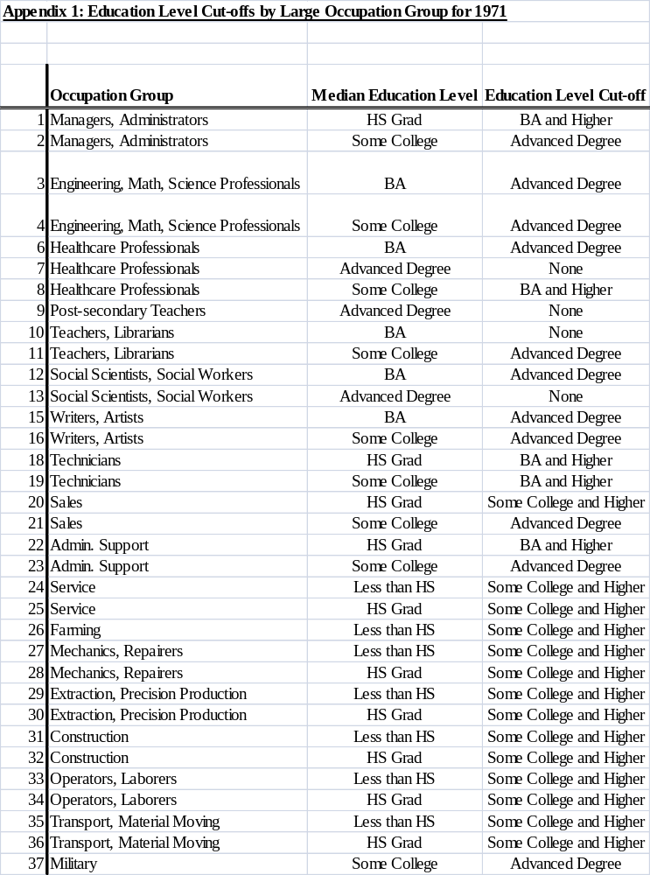
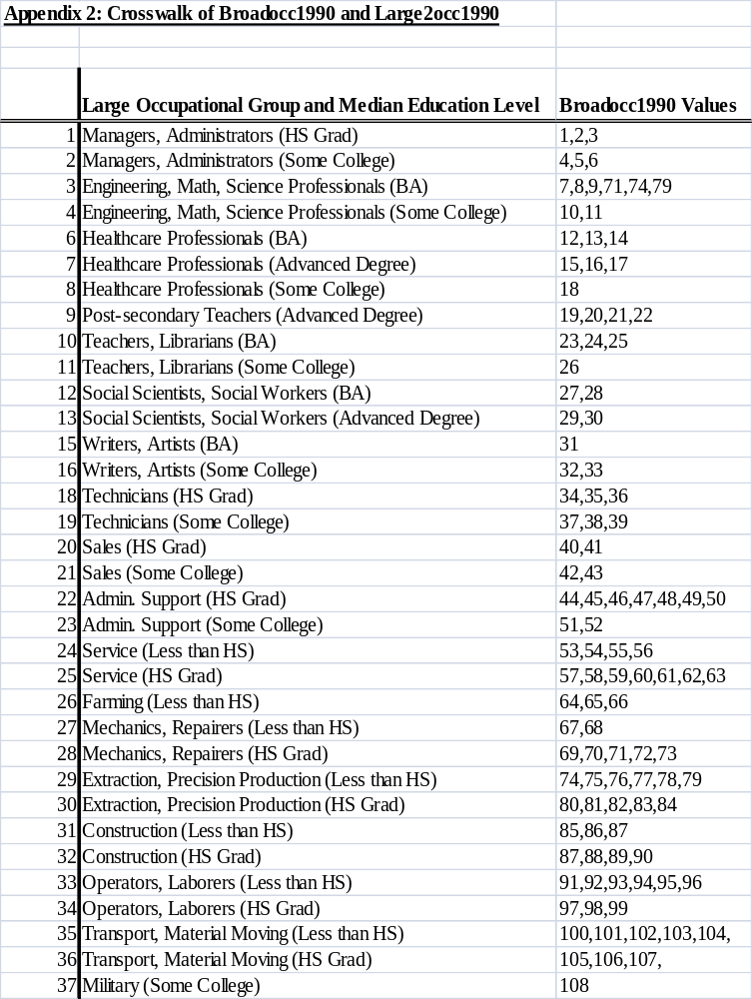
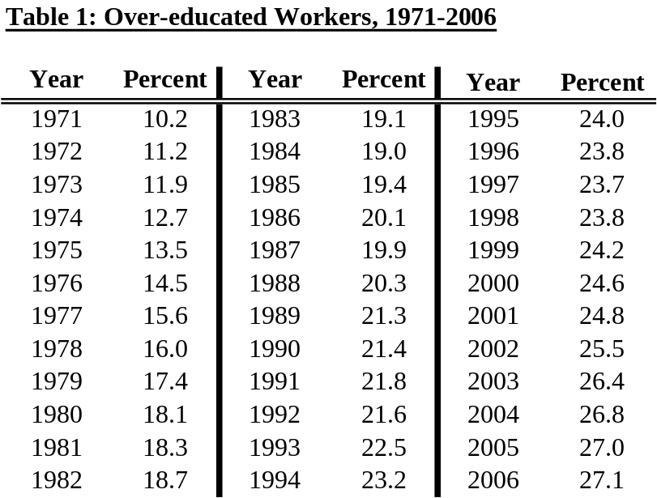

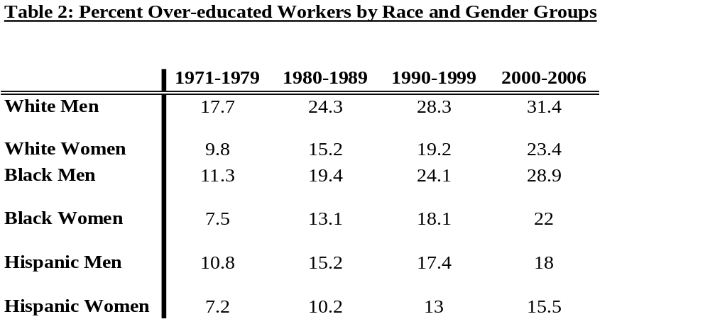

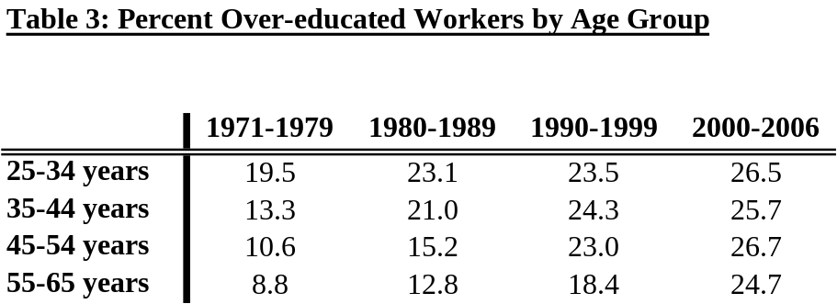
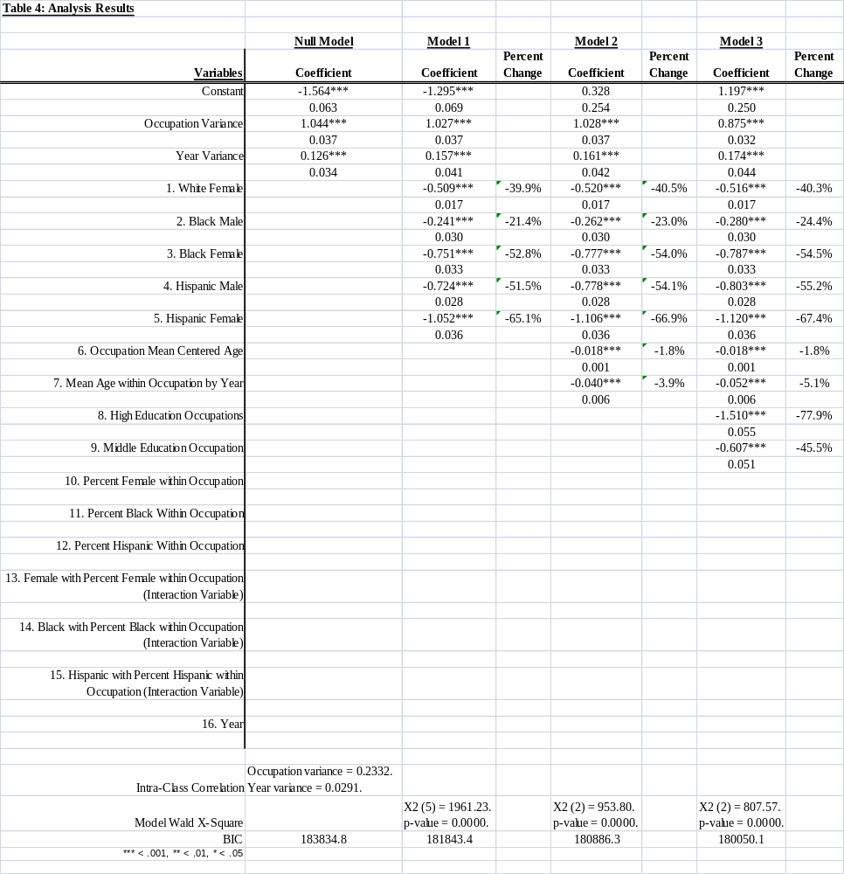

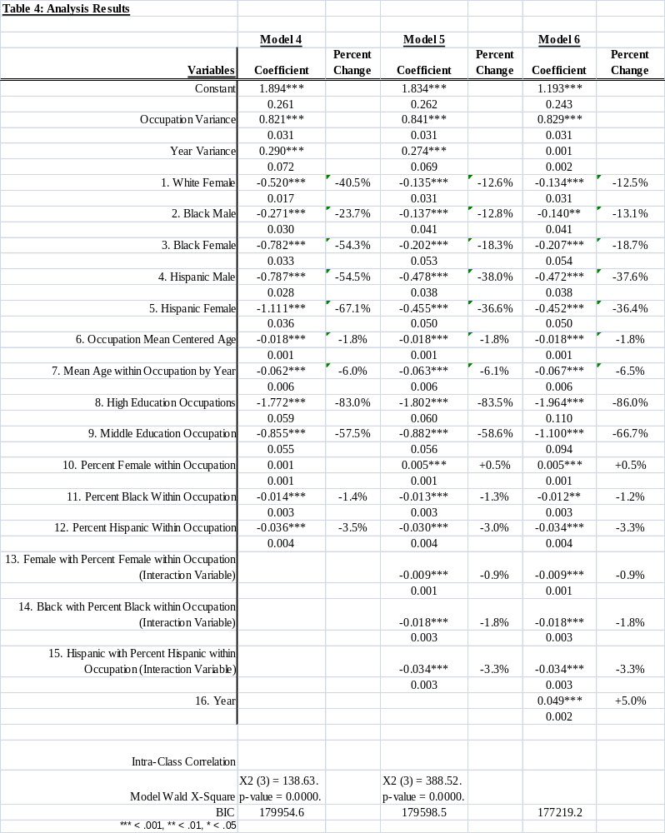

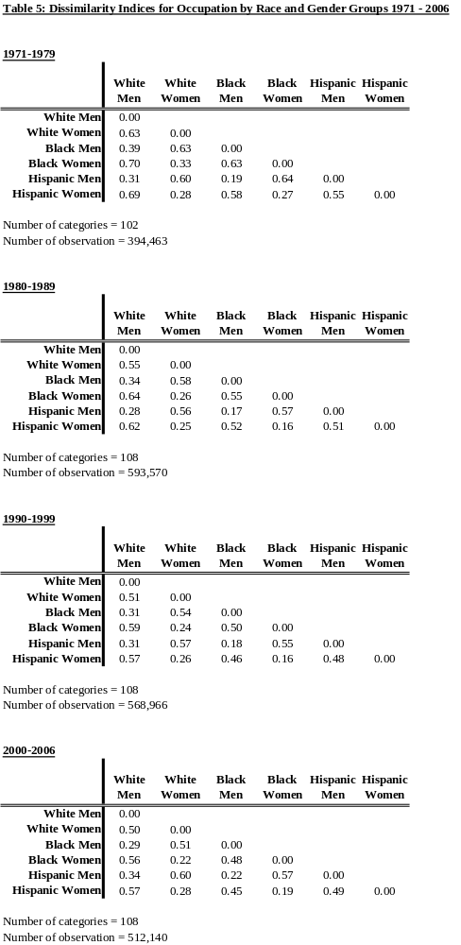
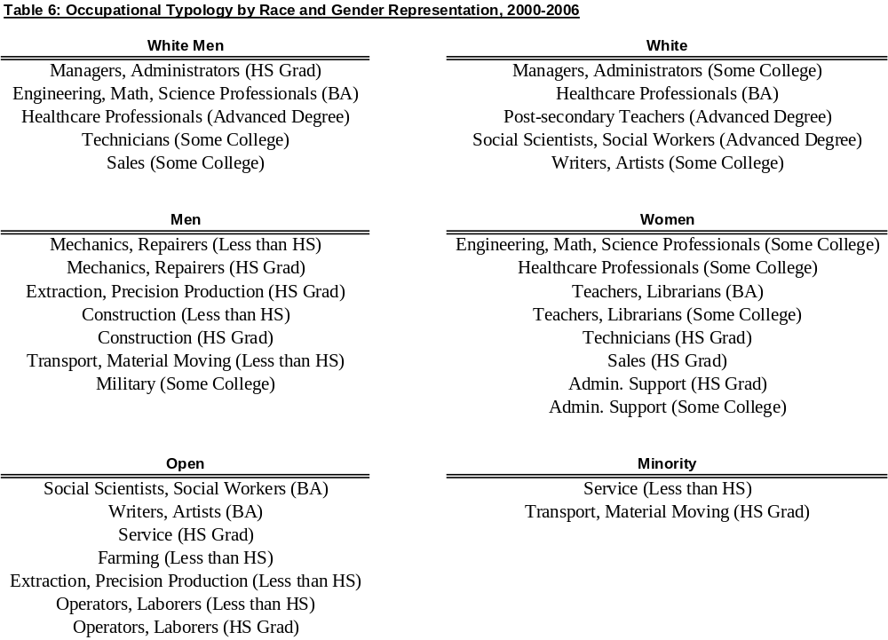

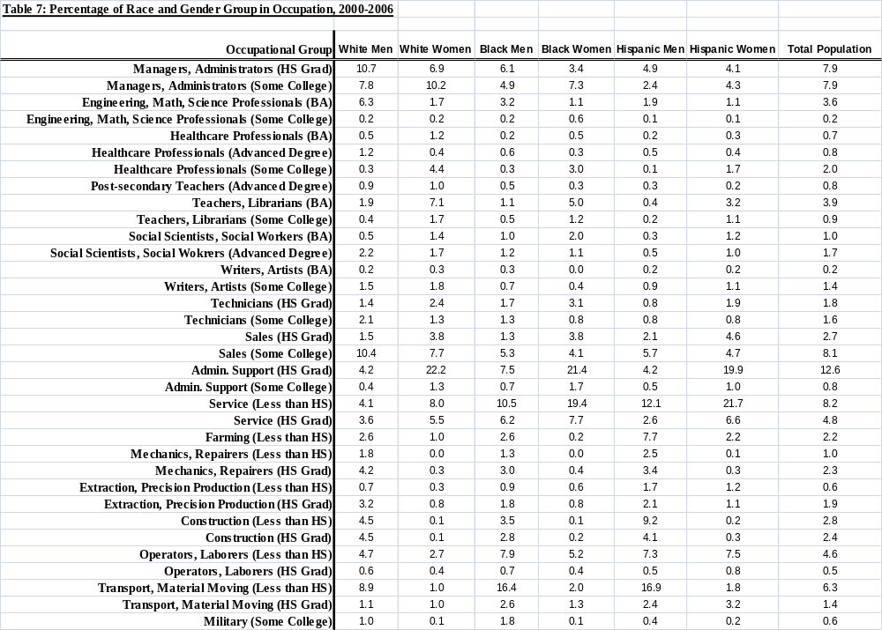

paper prepared for submission to 2010 International Labor Process Conference, New Brunswick, New Jersey.
I have chosen not to include worker education as an independent variable. The definition and measure of over-qualification includes both the occupation’s median education level and the worker’s education level. Because of this, over-education does not vary independently of worker education, particularly after controlling for occupation education level. Including both education variables in the analysis produces spurious effects for both variables and greatly inflates the occupation level variance.
To calculate these pseudo intra-class correlation coefficients I used pi² / 3 (3.28987) as the value for the level one residual variance.
Because the occupation demographic composition variables are centered on the 10th percentile, after including these interaction variables, the worker race and gender coefficients are interpreted as the effect of female and/or minority status for a worker in an occupation that is largely male or non-minority. Because of the high degree of occupational segregation, an occupation with the mean percentage of (for example) women workers will be considered a female typed occupation. I chose to center the occupation demographic composition variables on values that denote male or non-minority typed occupations in order to better illustrate the mediating effect of occupational segregation on race and gender disparities in over-education.
In this analysis, I say that a group has access to an occupation if the percentage of the group’s population in an occupation is at least as high as the population level percentage in the occupation.
For each occupation group I compared the percentage of each race and gender group employed in that occupation to the percentage of the total population employed in that occupation to determine which groups were over and under-represented in the occupation’s workforce.
White occupations include both white men and women, but no minority workers. Minority occupations include both minority men and women, but no white workers. Open occupations include either all women and at least one minority men’s group or all men and at least one minority women’s group.

